Report on Info Extractor

Introduction

Methodologies

Discussion

Conclusion

Recommendations

# Introduction

This report presents the findings of an analysis conducted on a computer system's network infrastructure by running a bash shell script. The purpose of the analysis was to evaluate the system's connectivity and performance, focusing on its public and private IP addresses, MAC address, CPU usage, memory usage, active system services, and largest files in the home directory.

The aim is to provide an understanding of the system's current state and offer recommendations for optimization (if possible).

# Methodologies

To gather the necessary data for this report, a Bash script was executed on the system. This script retrieved information about the network's public and private IP addresses of the users which contains, MAC address, CPU usage, memory usage, active system services, and the largest files in the home directory.

* Public and Private IP Addresses: The script used the curl command to fetch the public IP address and the ip command to identify the private IP address.
* MAC Address: The script used the ip command to find the MAC address of the network interface and masked sensitive portions of it for privacy.
* CPU Usage: The script used the ps command to identify the top 5 processes using the most CPU resources.
* Memory Usage: The free command was used to display the system's memory usage statistics, including total and available memory.
* Active System Services: The script used the systemctl command to list active system services and their statuses.
* Largest Files in Home Directory: The script used the find and du commands to locate the top 10 largest files in the /home directory.

# Discussion

The analysis revealed several findings that are worth noting, I’ll go through it in a step by step approach to better explain on each steps and flag that I’ve used:

| #!/bin/bash |
| --- |

This is called the Shebang line, it tells the system what interpreter to use to run the commands written within the script.

| separator () {  echo "---------- ---------- ----------" } |
| --- |

I’ve created a separator function for visual separation between sections for easier reading.

Now that the interpreter and easier reading formatting of the output is done, let’s go in depth of the command and flag(s) used

## Public and Private IP Addresses

### Public IP Address

| # The first command will be run to get and display your external/public IP Address. public_ip=$(curl -s ifconfig.io) separator  echo "Your External/Public IP Address is: $public_ip" |
| --- |

A public IP address is the outward-facing (public-facing) IP address assigned to the router by the internet service provider (ISP). The router uses its public IP to access the internet.

Other computers on the internet use your public IP address to communicate with the devices on your network

Let’s break down the command public_ip=$(curl -s ifconfig.io)

* The fetched public IP is stored in the public_ip variable.
* The $ symbol used here will place the whole command into the variable public_ip
  + This helps with getting the code cleaner for any user who wants to read the whole script. It’s definitely easier to read a command as a variable than the command in its long form.
* The curl command fetches the public IP address from the ifconfig.io service.
* The -s flag tells curl to operate silently without outputting progress information.

| echo "Your External/Public IP Address is: $public_ip": |
| --- |

* The echo command prints a message with the retrieved public IP address.
  + I used ” “ here as there is a variable used.
  + ’ ‘ will forcefully output anything in the single quotes and a string.

### Private IP Address

| # The second command will be run to get and display your internal/private IP Address. private_ip=$(ip addr show | grep -Eo 'inet [0-9.]+' | grep -v '127.0.0.1' | awk '{print $2}') separator  echo "Your Internal/Private IP Address is: $private_ip" |
| --- |

A private IP address is the address your network router assigns to your device. Each device within the same network is assigned a unique private IP address; this is how devices on the same internal network talk to each other.

Let’s break down the command private_ip=$(ip addr show | grep -Eo 'inet [0-9.]+' | grep -v '127.0.0.1' | awk '{print $2}')

* This line uses ip addr show to display network interface information.
* I used the grep command to filter lines that contain the word inet followed by an IPv4 address.
  + The -E flag tells grep to interpret the pattern as an extended regular expression
  + The -o flag tells grep to only output the parts of the line that match the regular
* The grep command -v '127.0.0.1' option excludes the loopback address.
* The awk command extracts the second field from the filtered lines, which contains the private IP address.
* The extracted private IP is stored in the private_ip variable.

The output will look like this in the terminal.

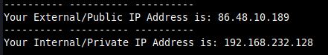

## MAC Address

| # The third command will be ran to get and display your MAC Address mac_add=$(ip addr show | grep link/ether | awk '{print $2}' | awk -F: '{print $1 ":XX:XX:" $4 ":" $5 ":" $6}') separator   echo "Your MAC Address is: $mac_add" |
| --- |

The MAC address was retrieved and masked appropriately to maintain security and privacy.

Let’s break down the command mac_add=$(ip addr show | grep link/ether | awk '{print $2}' | awk -F: '{print $1 ":XX:XX:" $4 ":" $5 ":" $6}')

* This line uses ip addr show to display network interface information.
* I used the grep link/ether command to filter lines containing the MAC address (link/ether).
* The awk '{print $2}' command extracts the MAC address.
* The awk -F: line masks the MAC address by keeping the first segment and replacing the second and third segments with XX.
* The masked MAC address is stored in the mac_add variable.

The output will look like this in the terminal



## CPU Usage

The top 5 processes using the most CPU resources were identified. These processes appeared to be system-related tasks.To achieve this, I used the ps and aux command with the --sort flag to have a better view of the top 5 processes using the most CPU resources.

Let’s break down the command ps aux --sort=%cpu | head -n 6:

* This command uses ps aux to list all processes with their CPU usage (%cpu).
* The output is sorted by CPU usage in descending order using --sort=%cpu.
* The head -n 6 command returns the top 6 lines from the sorted list

The output will look like this in the terminal

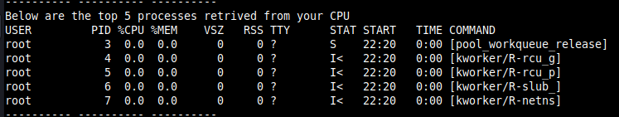

## Memory Usage

I’ve used the free command to get the memory usage of the system. The system had sufficient available memory, suggesting that it was not under significant memory pressure at the time of analysis.

Let’s break down the command free -h

* The free command is used to display memory usage statistics.
* The -h flag formats the output in human-readable format (e.g., using units like MiB or GiB).

The output will look like this in the terminal

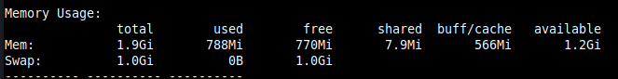

## Active System Services

The list of active services was consistent with a standard system configuration. I used the systemctl command with multiple flags to achieve this, I’ll explain below

I’ll break down the command used systemctl list-units --type=service --state=active --no-pager

**systemctl:**

* This is the command-line interface for interacting with systemd.
  + It allows you to manage services, units, and other system components.
* list-units:
  + This systemctl subcommand lists system units.
  + Units are objects that systemd manages, such as services, sockets, mounts, and timers.
* --type=service:
  + This option filters the list to include only units of type "service".
  + Services are units that manage long-running processes.
* --state=active:
  + This option filters the list to include only units in the "active" state.
  + The "active" state means that the service is currently running and operational.
* --no-pager:
  + This option disables the use of a pager (such as less or more) to display the output.
  + Without this option, the output might be passed through a pager, which can be inconvenient for scripting or for those who prefer to see all output at once.

Here is how the output will look like in the terminal

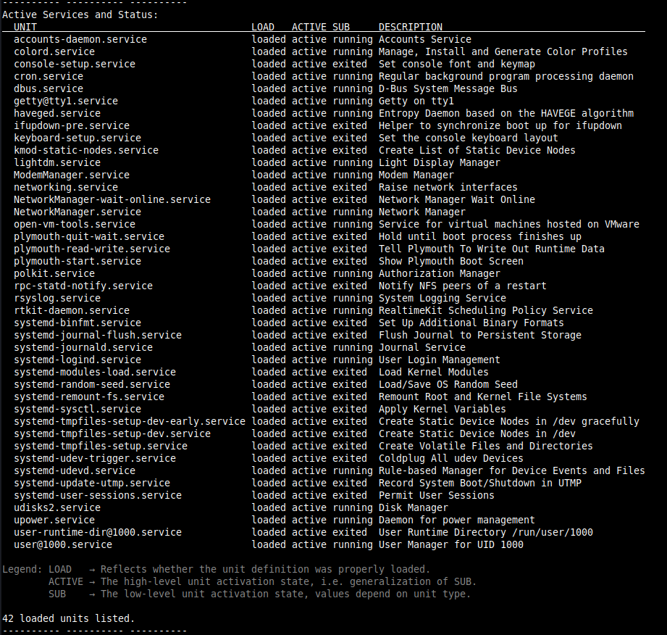

## Largest Files in Home Directory

To show the largest files in the home directory were related to the user's activities and software installations. I used the find, du, command to extract the information out.

Lets break down the command I used find "$HOME" -type f -exec du -h {} + | sort -rh | head -n 10

find "$HOME" -type f:

* The find command searches through files and directories.
* The argument "$HOME" specifies the location to search, which is the user's home directory (e.g., /home/username on Linux).
* The flag -type f tells find to only search for regular files, ignoring directories and other types of objects.

-exec du -h {} +:

* The -exec flag of the find command allows you to execute a specified command on each file found.
* The du command provides the disk usage of the specified path (a file or directory) and its contents.
* In this case, du -h is the command to execute, using the -h flag which calculates the disk usage of each file in a human-readable format (e.g., using units like KB, MB, GB).
* The {} symbol is a placeholder for each file found.
* The + at the end allows find to pass multiple files at once to du, which is more efficient than calling du separately for each file.

sort -rh:

* The sort command sorts the output.
* The -r flag sorts the output in reverse order, from largest to smallest.
* The -h flag allows the sort to consider human-readable units (e.g., KB, MB, GB) when comparing sizes.
* The head command displays the first few lines of the input.
* The -n 10 option specifies that only the first 10 lines of sorted output should be displayed.

This is how the output will look like in the terminal

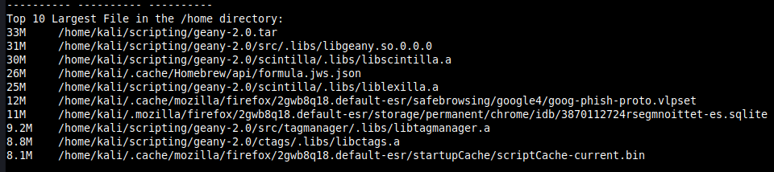

# Conclusion

The analysis of the computer system's network infrastructure reveals a healthy and well-configured environment. Here's a summary of the findings:

## Connectivity:

The system has both a valid public and private IP address, ensuring its ability to communicate within the local network and over the internet.

## Resource Utilization:

Available memory appears sufficient, and CPU usage seems to be primarily associated with expected system processes. This indicates that the system is not currently experiencing performance bottlenecks due to resource constraints.

## Services:

Active system services align with a standard configuration, suggesting no unexpected or potentially problematic services in operation.

## File Storage:

The largest files within the home directory appear related to the user's work or software installs. No immediate indication of space pressure exists.

# Recommendations

Based on the findings, the following recommendations are provided to optimize system performance and security:

## Security:

* Mask the full MAC address for privacy reasons, especially if the report will be shared or stored.

## Usage:

* Please note that the code and command that was used within this script is designed for unix-based systems meaning this script will mainly work for Linux or macOS systems.
* If you are running on windows, you might have to do a linux command line installation through powershell with administrator mode turned on.
  + To install WSL: Open PowerShell as administrator and run: wsl --install (You might need to reboot)
  + Install a Linux distribution: Choose your preferred distro (Ubuntu, Debian, etc.) from the Microsoft Store.
  + Launch the Linux environment: Search for your installed distro in the Start menu.
  + Place your script in the Linux file system: You can access your Windows files from within the Linux environment (usually mounted under /mnt/).
  + Run the script: Navigate to the script's directory and execute it using bash script_name.sh

## References:

* <https://developer.ibm.com/articles/what-is-curl-command/>
* <https://www.linode.com/docs/guides/how-to-use-the-linux-ip-command/>
* <https://en.wikipedia.org/wiki/MAC_spoofing#:~:text=The%20process%20of%20masking%20a,computer's%20identity%2C%20for%20any%20reason>.
* <https://wiki.archlinux.org/title/MAC_address_spoofing>
* <https://www.ibm.com/docs/en/aix/7.3?topic=p-ps-command#:~:text=The%20ps%20command%20writes%20the,display%20extra%20thread-related%20columns>.
* <https://www.geeksforgeeks.org/ps-command-in-linux-with-examples/>
* <https://www.linode.com/docs/guides/use-the-ps-aux-command-in-linux/>
* <https://www.geeksforgeeks.org/free-command-linux-examples/>
* <https://gcore.com/learning/how-to-use-systemctl-command-in-linux/#:~:text=The%20systemctl%20command%20in%20Linux%20is%20a%20utility%20that%20manages,default%20on%20many%20Linux%20distributions>.
* <https://www.tecmint.com/list-all-running-services-under-systemd-in-linux/>
* <https://bbs.archlinux.org/viewtopic.php?id=276103>
* <https://www.redhat.com/sysadmin/du-command-options>
* <https://superuser.com/questions/638375/what-does-mean-in-find-in-linux>
* <https://man7.org/linux/man-pages/man1/sort.1.html>
* <https://github.com/jlevy/the-art-of-command-line>